USER REQUIREMENTS

The Bidder should provide the following in the specified order in Section 4 of the proposal/bid document.

Provide detail information of the proposed solution as per document enclosed. Please note that marking should be carried out in the following manner; The Remarks column should be used to explain or provide detail information.

DESCRIPTION | REMARKS
Rating - 5 | If the User requirement is met 100% as defined in the RFP without any work around method.
Rating - 4 | If the User requirement is met 75% as defined in the RFP without any work around method. Define the number of hours required for the modification and cost in US$ in the Remarks column, in order to provide 100% functionality as defined.
Rating - 3 | If the User requirement is met 50% as defined in the RFP without any work around method. Define the number of hours required for the modification and cost in US$ in the Remarks column, in order to provide 100% functionality as defined.
Rating - 2 | If the User requirement is met 25% as defined in the RFP without any work around method. Define the number of hours required for the modification and cost in US$ in the Remarks column, in order to provide 100% functionality as defined.
Rating - 1 | If the User requirement is met as a Work around method defined in the RFP. Define the number of hours required for the modification and cost in US$ in the Remarks column, in order to provide 100% functionality as defined.
Rating - 0 | If the User requirement is not met as a defined in the RFP and modifications are required. Define the number of hours required for the modification and costs in US$ in the Remarks column.

The NBL rating is as follows:
1 = critical; 2 = essential; 3 = nice to have

MIS REPORTING
Ref : | User requirements | NBL Priority | Bidder’s Rating | Bidder’s Remarks
 | MIS Reporting
 | Customer Profitability | 1 | 5 | T24 has similar enquiries/reports which are produced using T24 MI module. We are assuming that the format of these enquiries and reports meet the requirements of NDB. If not, then NDB can use T24 Enquiry and Report designer tools to modify them.  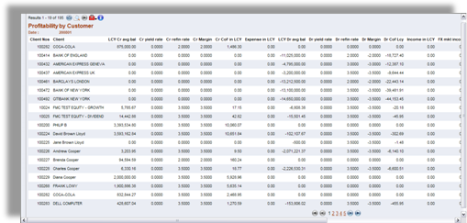  Figure 1. Profitability by Customer
 | Product Profitability | 1 | 4 | These types of reports are handled by T24 Management Information (MI) module. The module includes parameter tables to define profitability rules which will determine the type of profitability enquiries/reports to be produced.  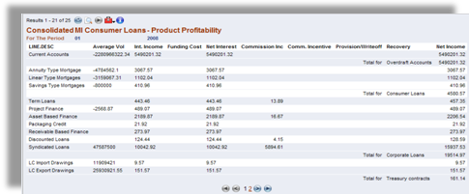  Figure 2. Example of a Loan Profitability enquiry/report in T24
 | Branch Profitability | 1 | 5 | Supported by similar MIS reports. In addition a Bank user can utilize either T24 Enquiry designer or T24 Report Designer to construct a report. The report can be in the form of online enquiries (i.e. using T24 Enquiry designer) or in the form of hardcopy reports produced during a Close of Business. In addition, T24 Enquiry designer includes a wizard function to guide a user to design simple enquiries.  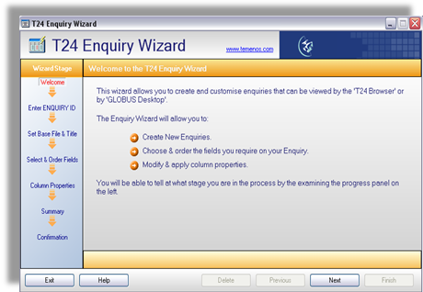  Figure 3. T24 Enquiry Wizard to guide users in designing enquiries
 | Region Profitability | 1 | 4 | A Bank user can utilize either T24 Enquiry designer or T24 Report Designer to construct a report. The report can be in the form of online enquiries (i.e. using T24 Enquiry designer) or in the form of hardcopy reports produced during a Close of Business. In addition, T24 Enquiry designer includes a wizard function to guide a user to design simple enquiries. (Please refer to 3 above for illustration of the Enquiry Wizard).
 | P&L and BS per branch and Consumer Bank as a whole | 1 | 5 | Provided by similar standard reports from T24 GL functionality.  In addition different types financial reports can be defined and generated out of the Consolidated Reporting Base (CRB) of T24.  The GL functionality consists of two main components, one which controls the updating of the CRB base with the data passed across from the individual applications while the other component covers the production of the reports. The CRB maintains data based on various parameters - including 4 fixed parameters and 12 Variable parameters at customer and application level.  The CRB reporting tool is a specialized report generator for general ledger reports such as general ledger reports, balance sheets and profit and loss reports. It only operates with the general ledger system and contains powerful tools to format columns, line definitions and other facilities associated with financial reports. Any financial data can be mapped into various Account Charts in the required way of grouping.  CRB reports can be produced at three levels; summary, deal/account level and audit entry level thus providing a clear and powerful drill-down facility to reconcile and justify the general ledger information. Reports can easily be produced by currency, in local currency, etc.  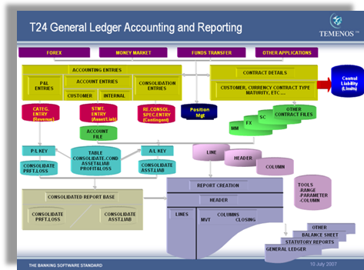  Figure 4. General Ledger Accounting and Reporting  Some complex reports can be customized as per the bank's requirements using the information available in T24 and through a flexible enquiry / report generation tool in T24.
 | Deposits of Consumer bank by each product and currency | 1 | 5 | T24 allows a Bank to enquire on the deposits by product and currency.  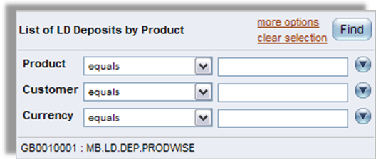  Figure 5. Enquiry List of deposits  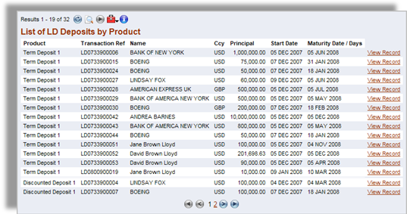  Figure 6. Result of List of deposits enquiry
 | Assets of Consumer Bank by Product | 1 | 5 | T24 has similar enquiries/reports which are produced using T24 Enquiry or Report designer. We are assuming that the format of these enquiries and reports meet the requirements of NDB. If not, then NDB can use T24 Enquiry and Report designer tools to modify them.  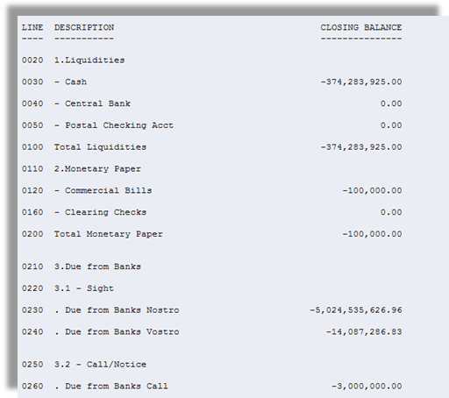  Figure 7. Extract of a standard report in T24  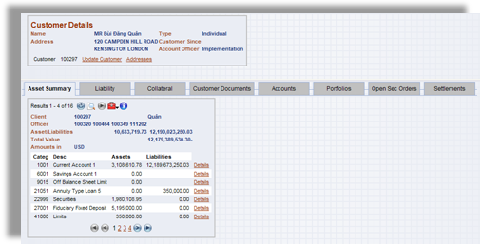  Figure 8. Example Asset Summary
 | Consumer Bank deposits by maturities, rates and by currency | 1 | 5 | T24 has similar enquiries/reports. We are assuming that the format of these enquiries and reports meet the requirements of NDB. If not, then NDB can use T24 Enquiry and Report designer tools to modify them.  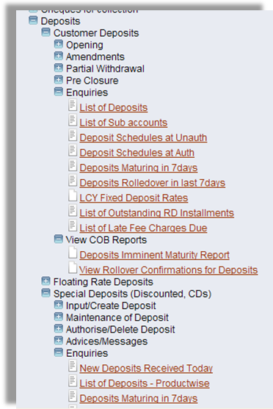  Figure 9. List of Deposits enquiries  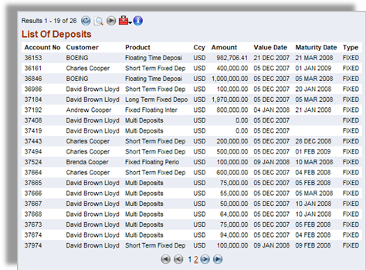  Figure 10. Example List of Deposits
 | Consumer Bank loans by maturities, rates and by currency | 1 | 4 | These are handled by T24 Loans module and Enquiry and Report designers. We are assuming that the format of these enquiries and reports meet the requirements of NDB. If not, then NDB can use T24 Enquiry and Report designer tools to modify them.  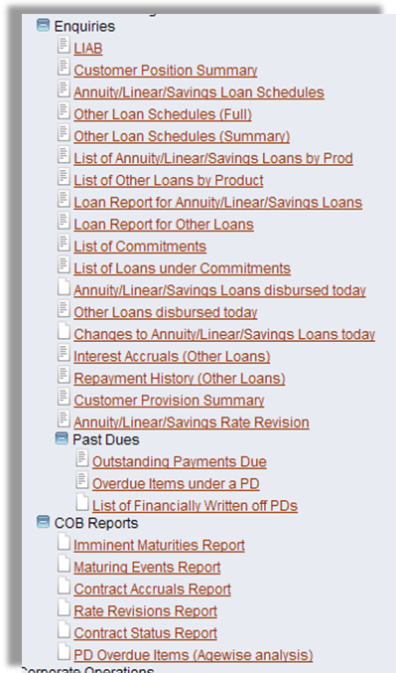  Figure 11. List of Loans enquiries  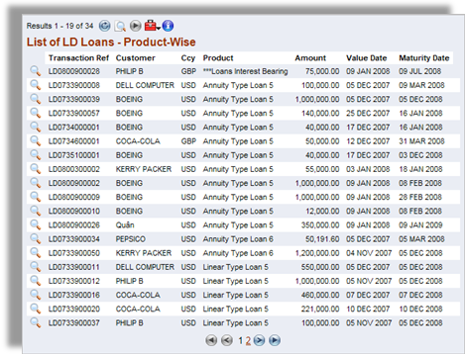  Figure 12. Example List of LD Loans
 | Global View of customers | 1 | 5 | T24 supported 360º Customer View:  - Designed from the client up, T24 is inherently a customer focused system. Out of the box functionality enables a single, comprehensive view of the client, their holdings, personal and business. In addition any relationships that are known can also be shown and details of these made available in a single view enabling Bank’s staff to have a total view of the client’s banking relationship.  - CRM functionality: T24 has powerful customer relationship management features available as integrated module within T24 supporting feature likes cross selling, up selling, propensity base sales, campaign management that can help Bank to leverage the customer base of related entities (Insurance, Securities) for developing Bank’s business  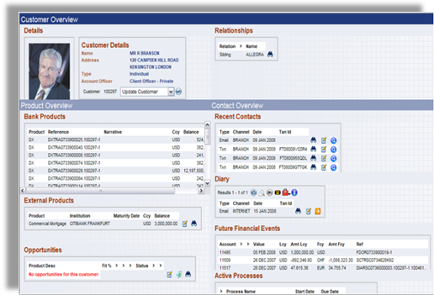  Figure 13. Global View of customers
 | Monthly movement of Consumer Bank deposits and loans by product rolling 12 months and end of previous year (Dec 31st) | 1 | 5 | Supported by T24.
 | Product profitability by Branch/ Region | 1 | 5 | T24 has similar enquiries/reports. We are assuming that the format of these enquiries and reports meet the requirements of NDB. If not, then NDB can use T24 Enquiry and Report designer tools to modify them.
 | RM Asset/Liability, volumes, with currency, rate, maturity, product breakdown | 1 | 5 | T24 has similar enquiries/reports which are produced using T24 MIS module. We are assuming that the format of these enquiries and reports meet the requirements of NDB. If not, then NDB can use T24 Enquiry and Report designer tools to modify them.  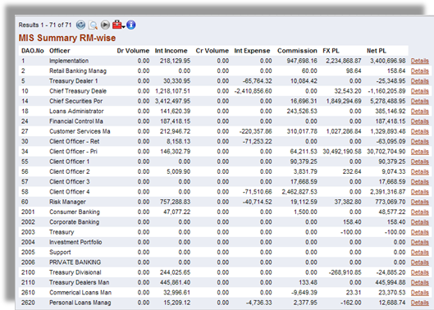  Figure 14. A T24 MIS Enquiry – RM wise  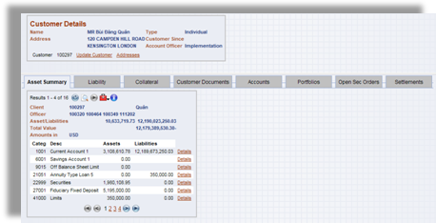  Figure 15. Customer Overview
 | RM portfolio profitability | 1 | 5 | Response same as 13 above.
 | Inflows – Number/Amount By Branch/Product/Currency/Size/Type of Transaction |  | 5 | Supported by T24 through Position Management functionality
 | Out flows – Number/Amount By Branch/Product/Currency/Size/Type of Transaction |  | 5 | Supported by T24 through Position Management functionality
 | Customer Acquisition by Product/Branch for a given period |  | 5 | Supported by T24.
 | New Accounts opened by product/branch for a given period |  | 5 | Supported by T24.
 | TP and Interest Rate per contract |  | 4 | A Bank user can utilize either T24 Enquiry designer or T24 Report Designer to construct a report. The report can be in the form of online enquiries (i.e. using T24 Enquiry designer) or in the form of hardcopy reports produced during a Close of Business. In addition, T24 Enquiry designer includes a wizard function to guide a user to design simple enquiries. (Please refer to 3 above for illustration of the Enquiry Wizard).
 | Margin per contract/product/branch |  | 4 | A Bank user can utilize either T24 Enquiry designer or T24 Report Designer to construct a report. The report can be in the form of online enquiries (i.e. using T24 Enquiry designer) or in the form of hardcopy reports produced during a Close of Business. In addition, T24 Enquiry designer includes a wizard function to guide a user to design simple enquiries. (Please refer to 3 above for illustration of the Enquiry Wizard).
 | Savings LKR Deposit Analysis |  | 4 | A Bank user can utilize either T24 Enquiry designer or T24 Report Designer to construct a report. The report can be in the form of online enquiries (i.e. using T24 Enquiry designer) or in the form of hardcopy reports produced during a Close of Business. In addition, T24 Enquiry designer includes a wizard function to guide a user to design simple enquiries. (Please refer to 3 above for illustration of the Enquiry Wizard).
 | Savings LKR New Accounts Opened |  | 4 | A Bank user can utilize either T24 Enquiry designer or T24 Report Designer to construct a report. The report can be in the form of online enquiries (i.e. using T24 Enquiry designer) or in the form of hardcopy reports produced during a Close of Business. In addition, T24 Enquiry designer includes a wizard function to guide a user to design simple enquiries. (Please refer to 3 above for illustration of the Enquiry Wizard).
 | Savings LKR Withdrawals GE 50,000 Analysis |  | 4 | A Bank user can utilize either T24 Enquiry designer or T24 Report Designer to construct a report. The report can be in the form of online enquiries (i.e. using T24 Enquiry designer) or in the form of hardcopy reports produced during a Close of Business. In addition, T24 Enquiry designer includes a wizard function to guide a user to design simple enquiries. (Please refer to 3 above for illustration of the Enquiry Wizard).
 | Account Wise New Customer Product report |  | 4 | A Bank user can utilize either T24 Enquiry designer or T24 Report Designer to construct a report. The report can be in the form of online enquiries (i.e. using T24 Enquiry designer) or in the form of hardcopy reports produced during a Close of Business. In addition, T24 Enquiry designer includes a wizard function to guide a user to design simple enquiries. (Please refer to 3 above for illustration of the Enquiry Wizard).
 | Badu malla Data Base  Minor Savings Accounts |  | 4 and 5 | Local enhancement for Badu malla Data Base.  Support for Minor Savings Accounts.
 | Minor Savings over 10000 |  | 5 | A Bank user can utilize either T24 Enquiry designer or T24 Report Designer to construct a report. The report can be in the form of online enquiries (i.e. using T24 Enquiry designer) or in the form of hardcopy reports produced during a Close of Business. In addition, T24 Enquiry designer includes a wizard function to guide a user to design simple enquiries. (Please refer to 3 above for illustration of the Enquiry Wizard).
 | New FDs over 10000 |  | 5 | A Bank user can utilize either T24 Enquiry designer or T24 Report Designer to construct a report. The report can be in the form of online enquiries (i.e. using T24 Enquiry designer) or in the form of hardcopy reports produced during a Close of Business. In addition, T24 Enquiry designer includes a wizard function to guide a user to design simple enquiries. (Please refer to 3 above for illustration of the Enquiry Wizard).
 | Number of Accounts Movement |  | 5 | A Bank user can utilize either T24 Enquiry designer or T24 Report Designer to construct a report. The report can be in the form of online enquiries (i.e. using T24 Enquiry designer) or in the form of hardcopy reports produced during a Close of Business. In addition, T24 Enquiry designer includes a wizard function to guide a user to design simple enquiries. (Please refer to 3 above for illustration of the Enquiry Wizard).
 | Number of new Customers Opened |  | 5 | A Bank user can utilize either T24 Enquiry designer or T24 Report Designer to construct a report. The report can be in the form of online enquiries (i.e. using T24 Enquiry designer) or in the form of hardcopy reports produced during a Close of Business. In addition, T24 Enquiry designer includes a wizard function to guide a user to design simple enquiries. (Please refer to 3 above for illustration of the Enquiry Wizard).
 | Officer Mismatch Reveal |  | ? | Would require more information to respond more accurately.
 | Savings LKR Deposits Analysis |  | 4 | A Bank user can utilize either T24 Enquiry designer or T24 Report Designer to construct a report. The report can be in the form of online enquiries (i.e. using T24 Enquiry designer) or in the form of hardcopy reports produced during a Close of Business. In addition, T24 Enquiry designer includes a wizard function to guide a user to design simple enquiries. (Please refer to 3 above for illustration of the Enquiry Wizard).

